Yarmer Class
Summer Term Curriculum Overview 2026

Welcome to Yarmer Class!

The children have a wonderful term of adventure, activities and learning awaiting them! Keep reading to see what we will be up to over the coming weeks!
This Term...
Next term, Yarmer will be diving into lots of exciting learning as summer begins to arrive. We will be learning all about plants, how they grow, and what they need to stay healthy. The children will also be exploring the world around them and noticing the changes that come with the warmer weather.
We are looking forward to spending more time learning outdoors and watching the children’s curiosity grow just like the plants they will be studying!
The Summer term always promises an incredible amount of learning as the children prepare for life in Year 1, and this term is no exception! We will be learning about what life is like in Year 1 before Shuffle Up Day later this term by interviewing some of the Year 1s about their experiences.
Our learning this term is based upon a range of high-quality texts that will expose the children to a rich range of language and vocabulary, enhanced by stunning illustrations, allowing the children to become lost in truly stunning stories as they explore the world.
The children will adore the breathtaking learning opportunities and experiences planned for this term which will leave them wanting more!

The Prime Areas: putting in solid foundations
Throughout the Summer term, we reflect back on the fabulous foundations the children have developed over the past two terms in their Prime Areas of Personal, Social and Emotional Development (PSED), Communication and Language (CL) and Physical Development (PD). The Prime Areas underpin every other aspect of a child’s development and learning throughout their time in the EYFS and beyond. In Yarmer we ensure that these foundation elements are strong and well developed enabling them to learn to soar through a successful lifetime of learning.
PSED
PSED underpins and flows throughout all our learning in Yarmer, helping us to learn and play alongside our friends. We will continue to strengthen our understanding and respect of others, as well as how we can diffuse difficult situations in a calm and fair way.
As a class, we continue to refer to and use our shared ethos that we wrote in September, helping us to show the fabulous social, emotional and learning behaviours we are famous for in Yarmer. The children have several opportunities on a daily basis to undertake roles of responsibility.
Communication & Language
The children are taught in a language rich environment, exposing them to a plethora of vocabulary and explanations that help to deepen their learning and thinking. This area covers the skills of listening, speaking and thinking about their use of language. This is a key priority and we plan opportunities on a daily basis to enhance every child’s Communication and Language.
Physical Development
As well rounded, active citizens we will have lots of opportunities for positive competition in sport and other activities to build character and self-discipline. This term we will be focusing on this term is track and field. The children will be learning the skills needed to partake in a variety of different games as we prepare for Sports Day. The children have numerous daily opportunities for the children to develop their coordination, control, and movement to develop their fine and gross motor skills. The children will develop their fine motor skills through activities such as Funky Fingers challenges, regular scissor, brush and pencil control activities. We will also develop gross motor skills through ball control, simple gymnastic movements and coordination in our PE sessions. In Yarmer, we help children to understand the importance of a range of physical activity and to make healthy choices in relation to food.
The World Around Us
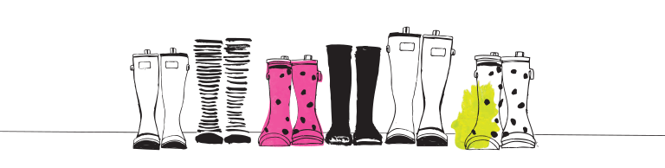
We are very fortunate that our beautiful school is located in such an amazing setting, surrounded by beaches and fields. Over the coming term, we will have another half term at Forest School with Pete from Forest & Beach. These opportunities allow the children to engage with and explore the local area, it’s fields, woodland and hedgerows. We look at the variety of wild plants and flowers growing in the fields and hedgerows. We will also observe and describe the seasonal changes we notice over the coming months.
All of our outdoor sessions not only allow the children to learn about nature and their environment, but also support the children’s Communication and Language development by encouraging them to explain and reason their ideas and thoughts. We also learn how to manage risk safely, learning how to light fires, use saws and drills and outdoor cooking.
Exploring people, culture and communities is a big part of life in Yarmer. As global citizens, the Reception children will be looking at the special places and stories that are precious to people of different faiths.

Mathematics
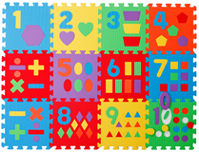
The children are supported to engage in a range of learning opportunities that allow them to demonstrate and explain their understanding of early mathematical concepts. The children will further develop their recognition of a range of numerals around the learning environment. We will use a range of practical, real-life problems to draw out the children’s thinking when it comes to early addition, subtraction and sharing. The children will be encouraged to record their mathematical thinking in a way that is meaningful to them.
We will also explore a range of simple 2D and 3D shapes, as well as investigating basic measures using everyday language to talk about size, weight, capacity, position, distance, time and money.
Given the fantastic foundation the children have built so far this year, they are in a brilliant place to make the move into Year 1!
Literacy
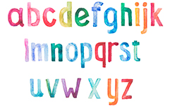
The development of Literacy here in Yarmer Class is focused on the immersion of the children in a language rich environment, securing their enjoyment and engagement with the written and spoken word.
We will share a variety of high quality texts, both fiction and non-fiction to explore authorial voice and writerly craft in an age appropriate way. The children will be introduced to and deepen their love of storytelling through our Favourite Five books and lots of gorgeously written class novels.
Phonics is taught using the Read Write Inc. programme which teaches children to read accurately and fluently with good comprehension. They learn to form each letter, spell correctly, and compose their ideas step-by-step.
The children in Reception will be encouraged and supported to make marks and write by tapping into their interests through a range of learning opportunities throughout the learning environment and through their Learning Play.
Expressive Art & Design

As artists and designers in Yarmer, we will be investigating and experimenting with a range of drawing, painting and 3D construction materials. The children will create their own pieces inspired by Australian artists and other abstract artists. The children will be introduced to and develop their understanding and use of simple colour techniques, including colour mixing, shade and tone. We will also learn about artists and some of the techniques they used to create their art.
Christian Distinctiveness

Through our daily Acts of Worship, we will reflect on how we demonstrate our Christian values in school and within our local and world communities. We also weave our Christian values into the children’s learning opportunities and activities.
Family Group Acts of Worship
Each week, the children will join together as a whole school to deepen their understanding of the themes covered in our whole school Acts of Worship. These sessions offer a wonderful opportunity for all children to come together and work collaboratively as a family.
Home Learning in Reception
We value the support that parents and families provide from home. It enriches your child’s learning and helps them achieve the best that they can.
In Reception, this will consist of a range of books home weekly and some fun Phonics and maths activities to support the fabulous learning they are doing in class. Occasionally, we may set a special project, investigation or experiment for you to work on together at home!
Regular reading is of HUGE importance to early literacy and oracy, as well as the social development of our young children. In the early days of school, it is vital that the children are not pushed to read, their love of books is the most important thing. You can support your child’s reading at home by encouraging them to:
- Name any sounds they recognise, such as the ones they see in their name.
- Ask them to predict the ending to the story and explain why.
- Ask questions to help them understand and enjoy the story.
- Listen to a wide variety of pleasurable books.
- Continue to read a variety of stories to your child so that they are hearing a variety of story language and develop a love of reading.
- Don’t forget bedtime stories are still important too!

